Ex.no:5
Date:4/4/25
5. Write a Servlet to demonstrate the difference between HTTP GET and POST
By creating a form and handling requests accordingly
Aim:
To Write a Servlet to demonstrate the difference between HTTP GET and POST
By creating a form and handling requests accordingly .

Program:
Sigh.html:
<!DOCTYPE html>
<html>
<head>
<meta charset="ISO-8859-1">
<title>Sign-Up Page</title>
</head>
<body>
<center>
<h1>Sign-Up Page</h1>
<form method="post" action="http://localhost:7750/Dynamic_web_project_shruthi/SignupDetails">
<p>
<label for="Firstname">First name :</label>
<input type="text" name="Firstname" placeholder="Enter your Firstname" >
</p>
<p>
<label for="Lastname">Last name :</label>
<input type="text" name="Lastname" placeholder="Enter your Lastname" >
</p>
<p>
<label for="dob">Date of Birth:</label>
<input type="date" id="dob" name="dob" required>
</p>
<p>
<label for="male">Gender : Male</label>
<input type="radio" id="male" name="gender" value="male">
<label for="female">Female</label>
<input type="radio" id="male" name="gender" value="female">
</p>
<p>
<label for="address">Address</label>
<textarea type="text" name="address"></textarea>
</p>
<input type="submit" value="SignUp">
</form>
</center>
</body>
</html>

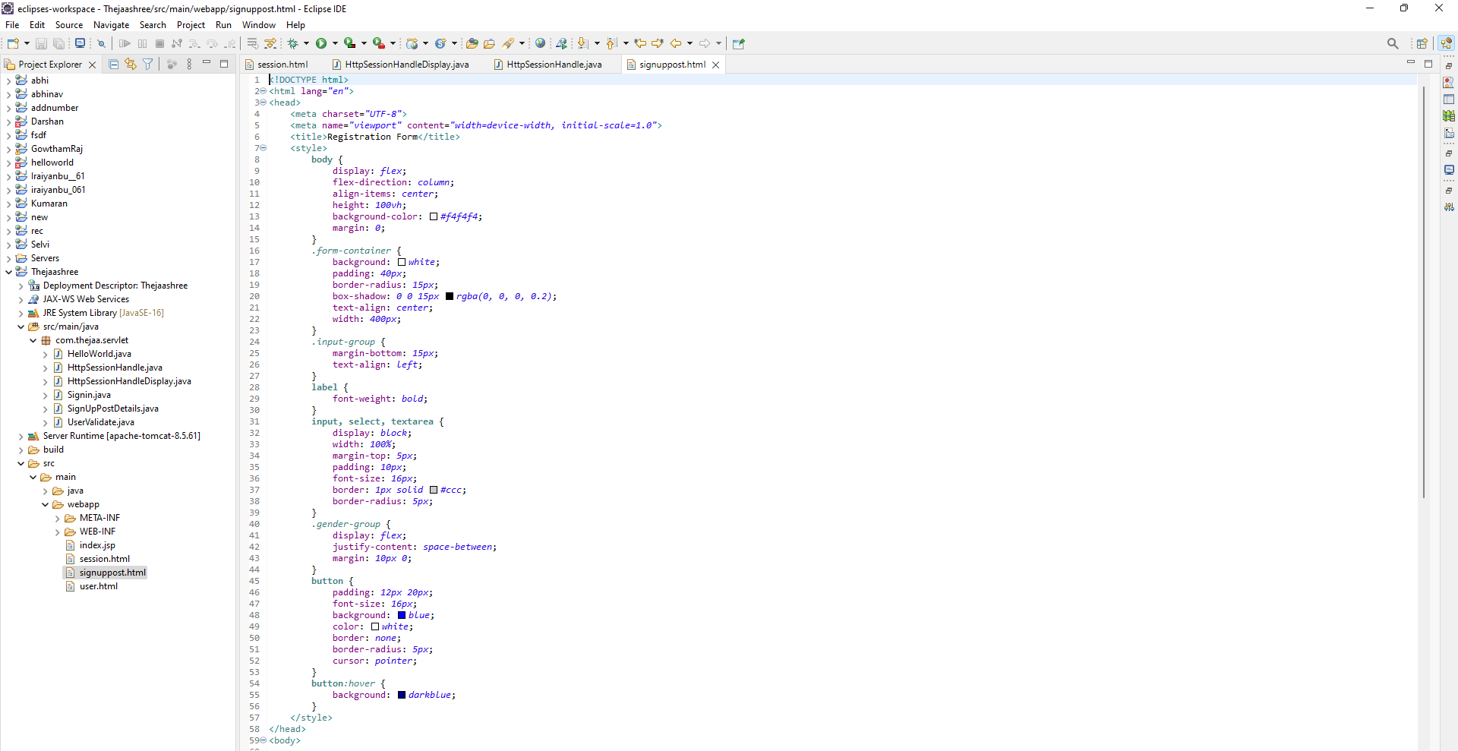

PostGet.java
package com.thejaa.servlet;
import java.io.IOException;
import java.io.PrintWriter;
import javax.servlet.ServletException;
import javax.servlet.annotation.WebServlet;
import javax.servlet.http.HttpServlet;
import javax.servlet.http.HttpServletRequest;
import javax.servlet.http.HttpServletResponse;
/**
* Servlet implementation class SignupDetails
*/
@WebServlet("/SignupDetails")
public class ex5 extends HttpServlet {
private static final long serialVersionUID = 1L;

/**
* @see HttpServlet#HttpServlet()
*/
public ex5() {
super();
// TODO Auto-generated constructor stub
}

/**
* @see HttpServlet#doGet(HttpServletRequest request, HttpServletResponse response)
*/
protected void doGet(HttpServletRequest request, HttpServletResponse response) throws ServletException, IOException {
// TODO Auto-generated method stub
response.getWriter().append("Served at: ").append(request.getContextPath());
}

/**
* @see HttpServlet#doPost(HttpServletRequest request, HttpServletResponse response)
*/
protected void doPost(HttpServletRequest request, HttpServletResponse response) throws ServletException, IOException {
String f_name=request.getParameter("Firstname");
String l_name=request.getParameter("Lastname");
String dob_v=request.getParameter("dob");
String gen=request.getParameter("gender");
String add=request.getParameter("address");

PrintWriter p = response.getWriter();

p.println("First Name: "+f_name+"<br>");
p.println("Last Name: "+l_name+"<br>");
p.print("Age: "+dob_v+"<br>");
p.print("Gender: "+gen+"<br>");
p.print("Address: "+add+"<br>");
}

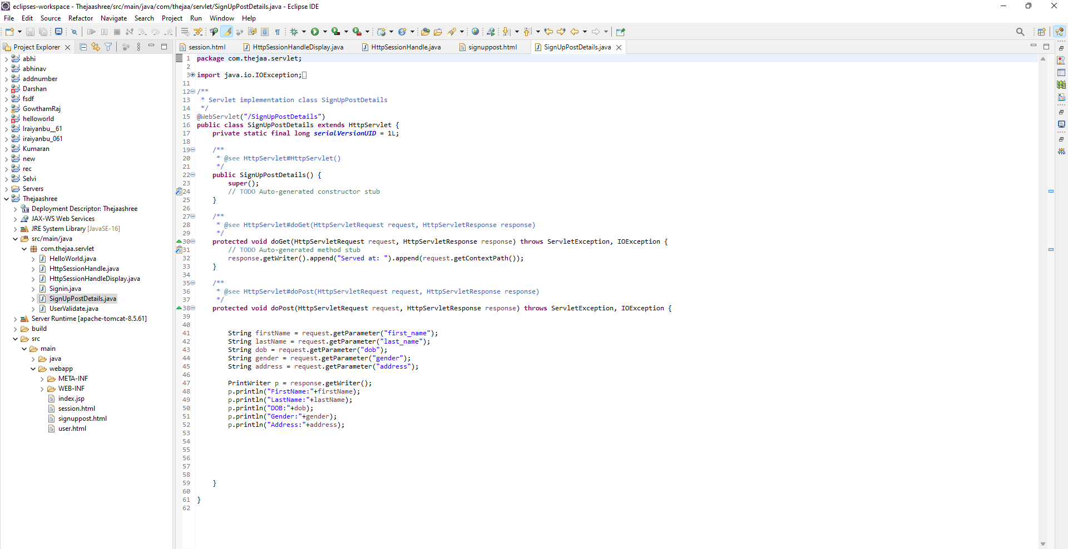

Output:

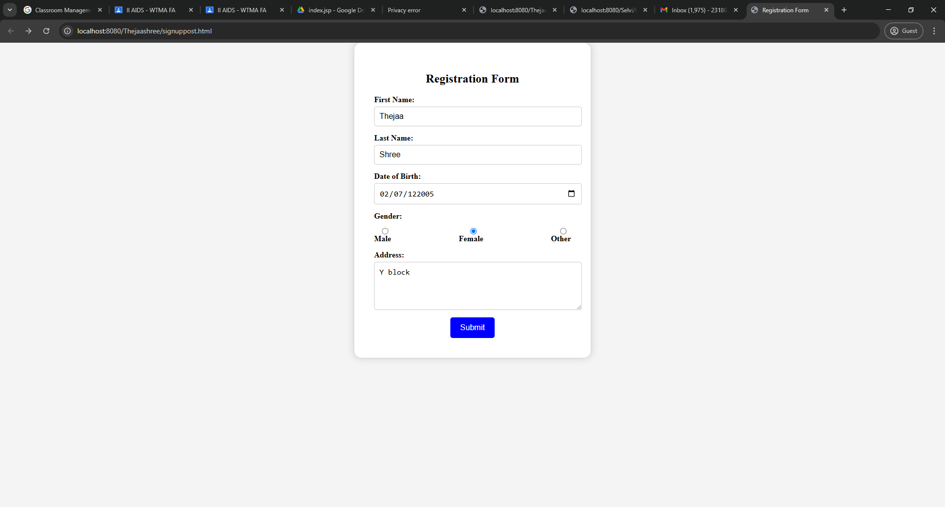
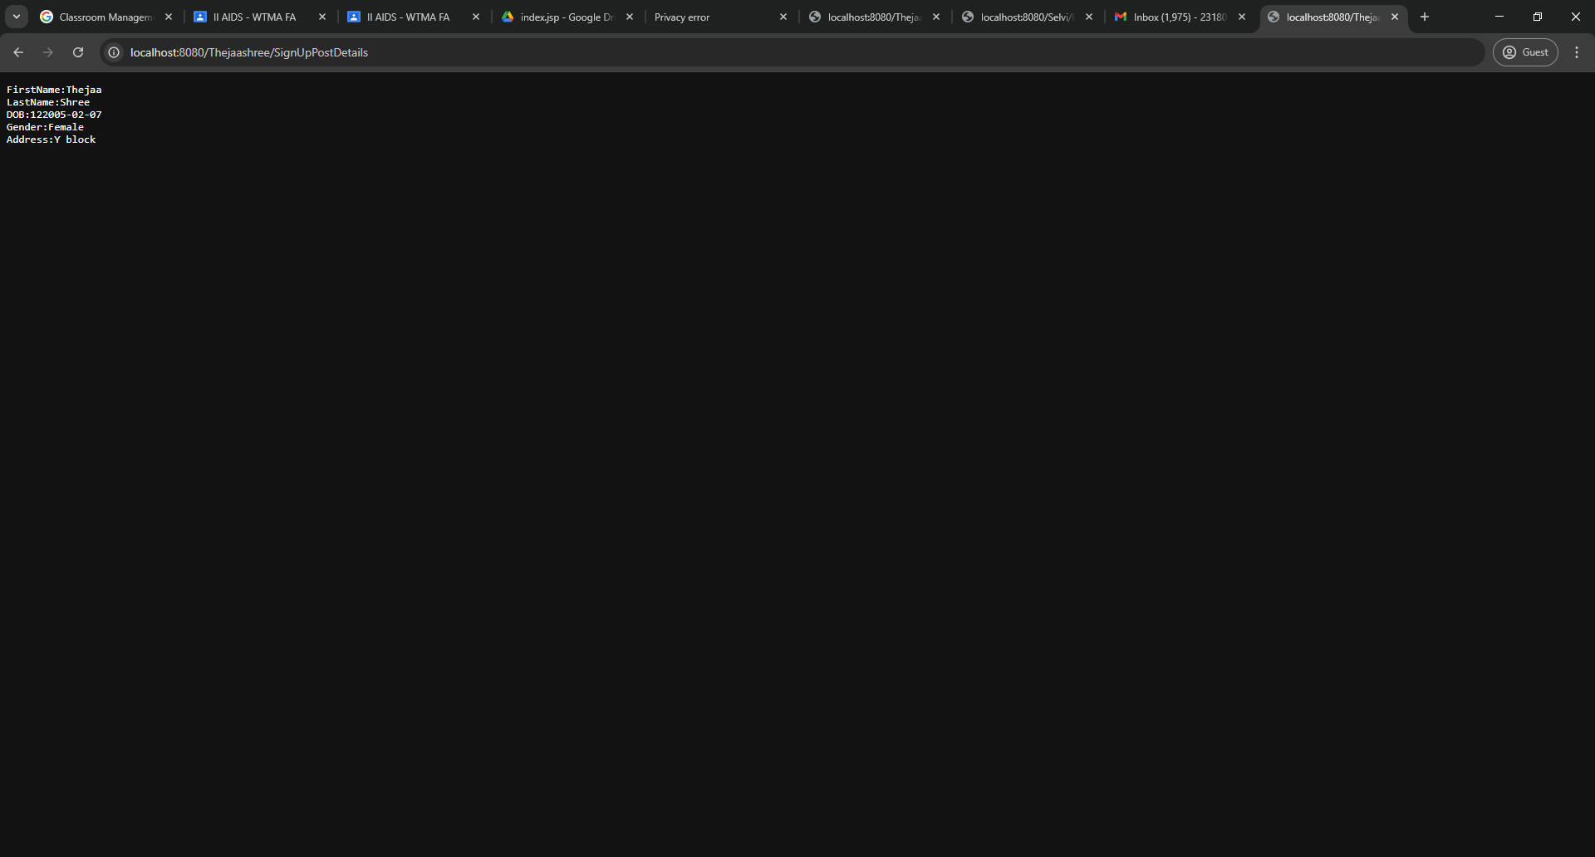

Result:
Thus the program was executed successfully on web browser and Servlet to demonstrated the difference between HTTP GET and POST By creating a form and handling requests accordingly

